**Tic-Tac-Toe using Socket Programming**

**Computer Networks Mini Project**

Chitturi Sai Suman (1602-18-733-097)

Praneeth Kapila (1602-18-733-116)

**Abstract**

Socket programming is a way of connecting two nodes on a network to communicate with each other. One socket (node) listens on a particular port at an IP, while other socket reaches out to the other to form a connection. Server forms the listener socket while client reaches out to the server.

The game begins when server and client are connected. The client makes the first move and the corresponding move is sent over the TCP network. Then the board gets updated accordingly at both ends, server side and client side. Server and client make their moves alternatively until one of them wins or the game ends in a draw.

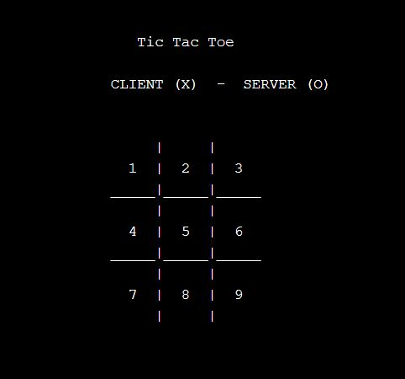

**The following are intended to be used in our project.**

**Protocol**: TCP

**Methods**: socket(), bind(), listen(), accept(), connect(), send(), recv(), checkwin() [To periodically to check the winner], board() [to set the game environment].

**Structure**: sockaddr_in for setting the ip family, address, portno.